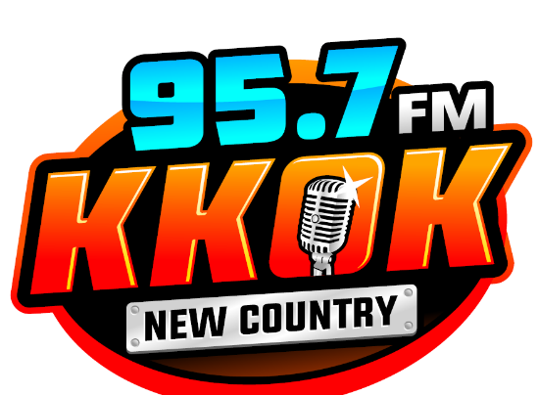 

EEO filing Report for the period 12 months December 1, 2023 through November 30, 2024.

KMRS 1230 AM and KKOK 95.7 FM did not meet the FCC criteria of 5 full time employees for filing of the Annual EEO Report.

This report was filed by:

Deborah Mattheis – General Manager of KMRS KKOK Radio